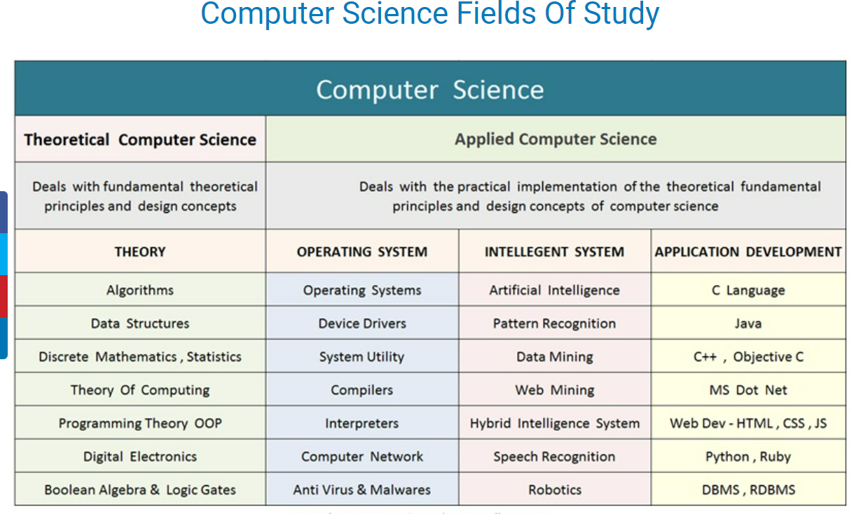

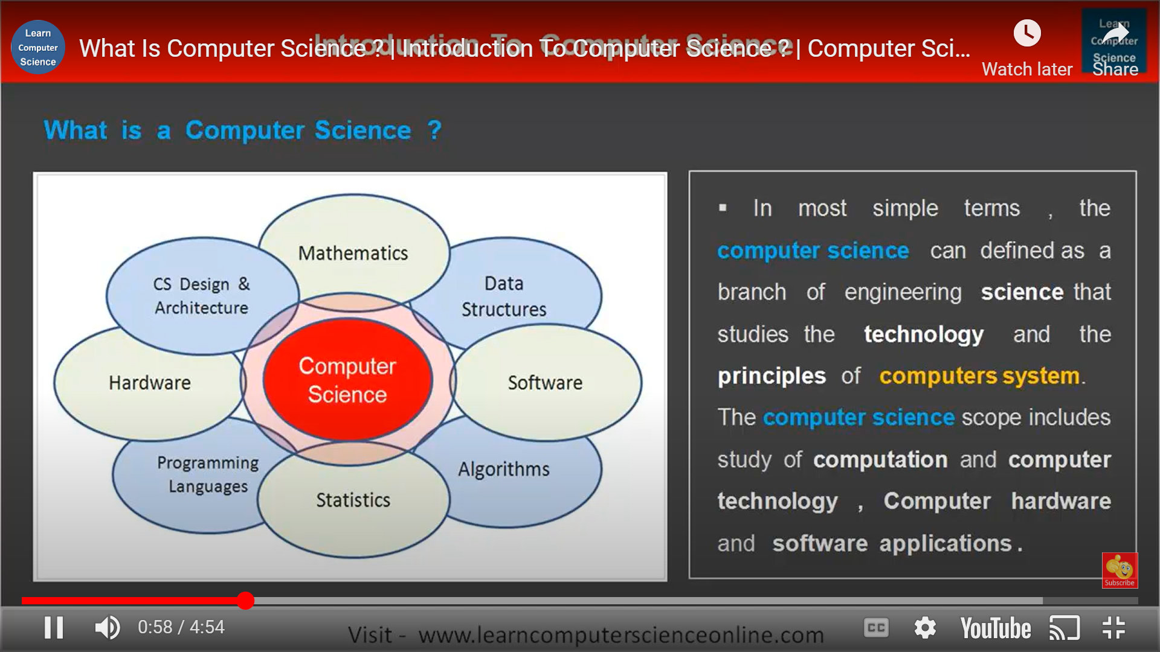

The above can further be broken down into:

|  |  |
| --- | --- |
| **Semester 1** | **Semester 2** |
| Calculus | Linear Algebra and Ordinary Differential Equations |
| Chemistry I | Modern Physics |
| Introduction to computer programming | Data Analysis and Interpretation |
| Economics | Abstractions and Paradigms in Programming |
| Chemistry Lab | Physics Lab |
| Workshop Practice | Abstractions and Paradigms in Programming |
| Engineering Graphics and Drawing |
| **Semester 3** | **Semester 4** |
| Numerical Analysis | Environmental  Studies |
| Introduction to Electrical and Electronic Circuits | Automata Theory and Logic |
| Discrete Structures | Design and Analysis of Algorithms |
| Data Structures and Algorithms | Logic Design |
| Experimentation and Measurement  Lab | Software Systems Lab |
| Data Structures and Algorithms Lab | Logic Design Lab |
| **Semester 5** | **Semester 6** |
| Literature/Philosophy/Psychology/Sociology | Artificial Intelligence |
| Computer Architecture | Implementation of Programming Languages |
| Operating Systems | Computer Networks |
| Database and Information Systems | Artificial Intelligence Lab |
| Database and Information Systems Lab | Implementation of Programming Languages Lab |
| Computer Architecture Lab | Computer Networks Lab |
| Operating Systems Lab |
| **Semester 7** | **Semester 8** |
| Elective 1 | Elective 4 |
| Elective 2 | Elective 5 |
| Elective 3 | Elective 6 |
| Institute Elective 1 | Institute Elective 2 |

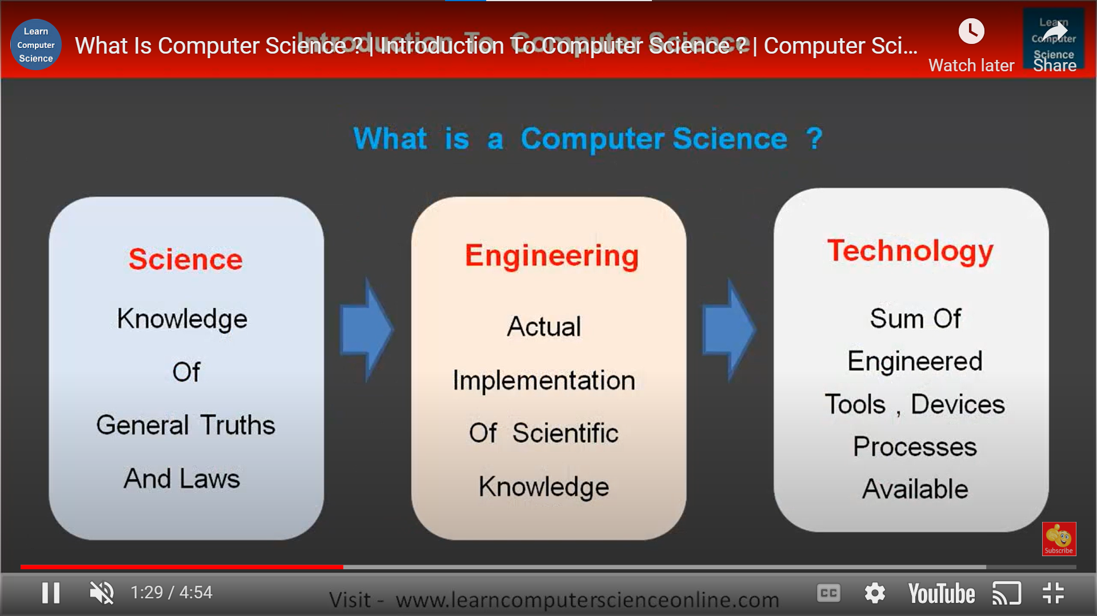

Automata theory

Spanning Tree algorithm

**Spanning tree**

A spanning tree is a sub-graph of an undirected connected graph, which includes all the vertices of the graph with a minimum possible number of edges. If a vertex is missed, then it is not a spanning tree.

The edges may or may not have weights assigned to them.

